**NLP Applications**

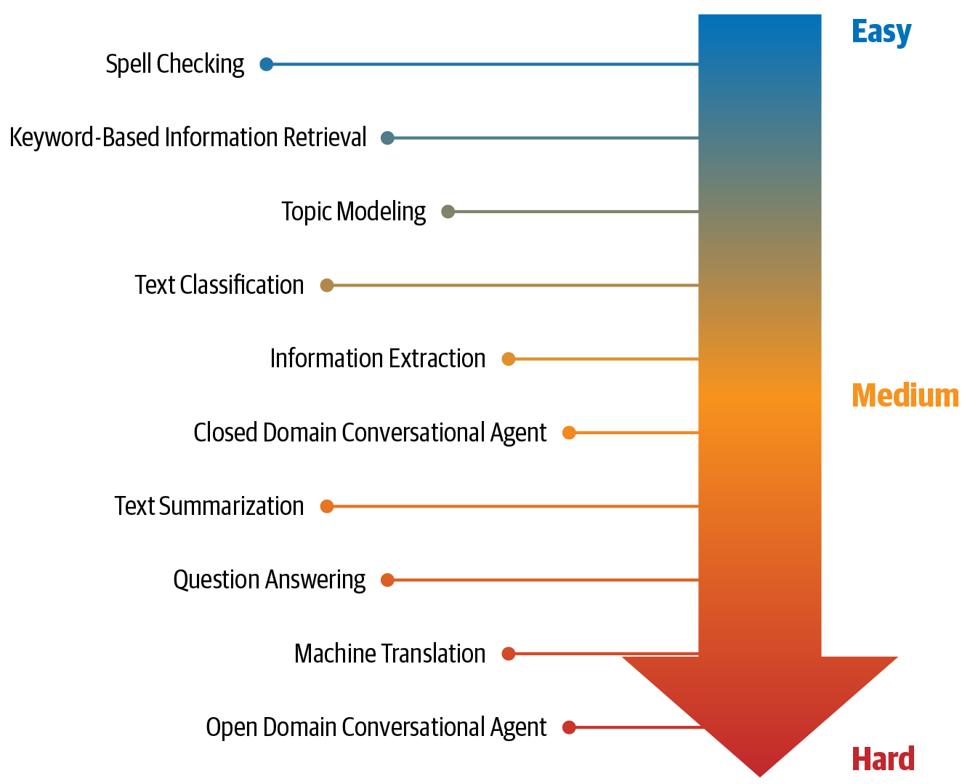

 Chatbot/Virtual Assistant

John: “How is the weather today?”

Digital assistant: “It is 37 degrees centigrade outside with no rain today.”

John: “What does my schedule look like?”

Digital assistant: “You have a strategy meeting at 4 p.m. and an all-hands at 5:30 p.m. Based on today’s traffic situation, it is recommended you leave for the office by 8:15 a.m.”

While he’s getting dressed, John probes the assistant on his fashion choices:

John: “What should I wear today?”

Digital assistant: “White seems like a good choice.”

**Sentiment Analysis**- product reviews or social media messages, the task is to figure out if the sentiment is positive, neutral or negative

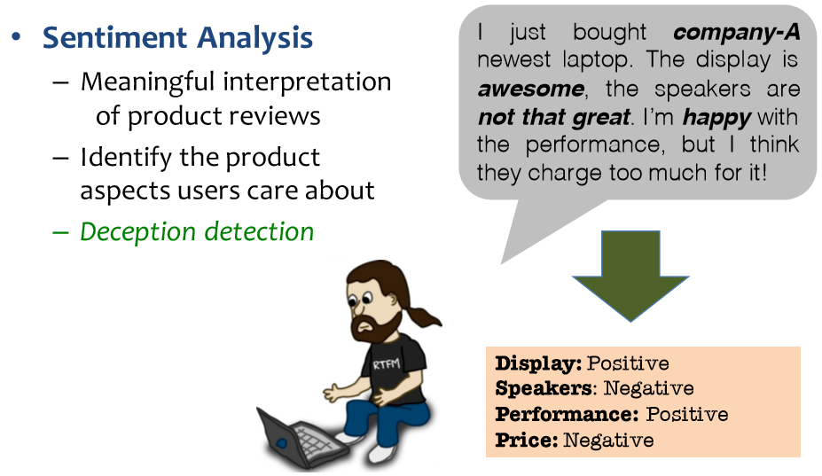

**Intent Analysis**Intent analysis steps up the game by analyzing the user’s intention behind a message and identifying whether it relates an opinion, news, marketing, complaint, suggestion, appreciation or query

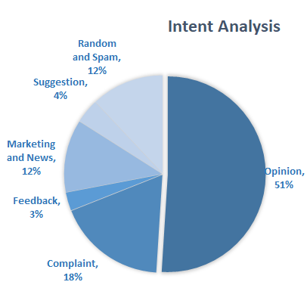

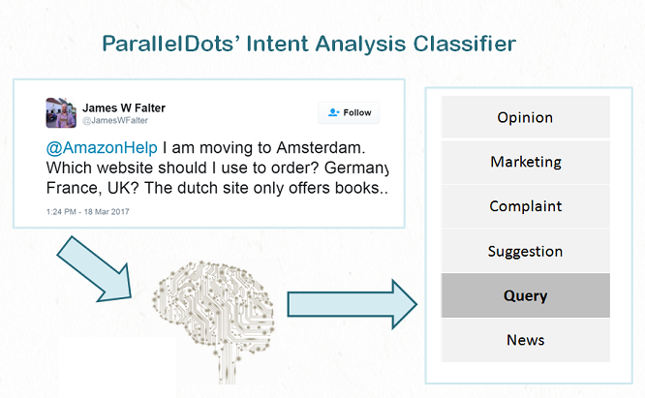

**Q&A, paraphrasing and summarizing**

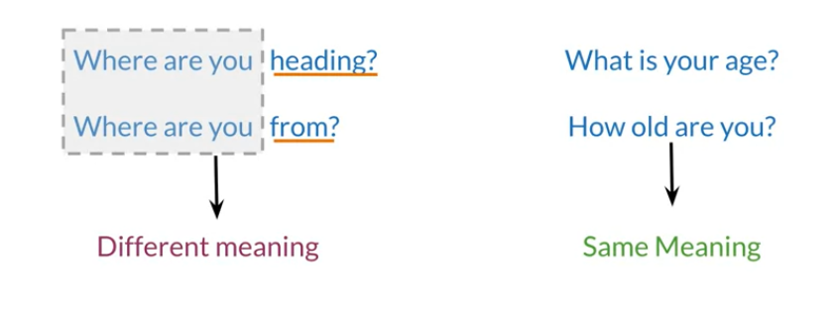

**Capture Dependencies**

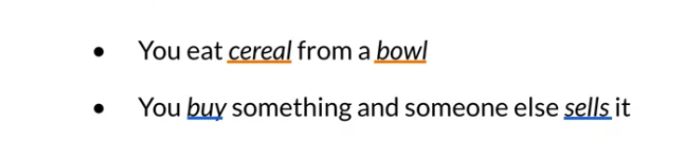

**Information search**



**AP- Robot Journalist**

<https://www.theverge.com/2015/1/29/7939067/ap-journalism-automation-robots-financial-reporting>

**Google Duplex**

<https://ai.googleblog.com/2018/05/duplex-ai-system-for-natural-conversation.html>

**Named Entity Recognition (Per,Org,Loc)**

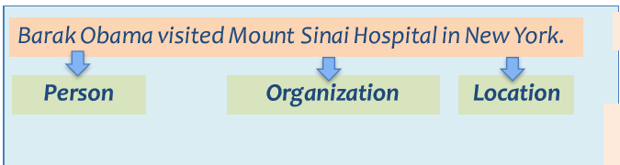

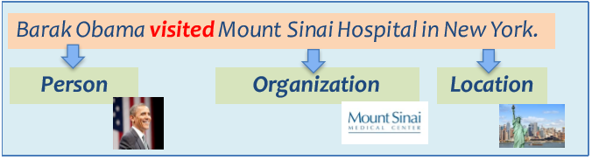

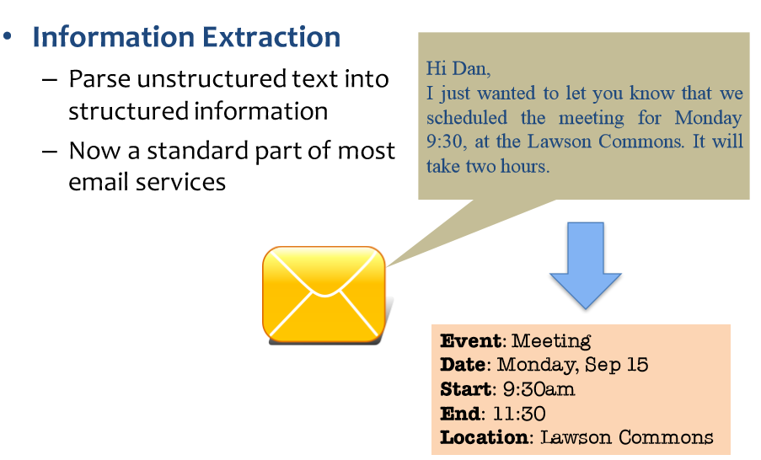

|  |  |  |
| --- | --- | --- |
|  |  |  |
| *Language modeling* | task of predicting what the next word in a sentence will be based on the history of previous words | building solutions for a wide variety of problems, such as speech recognition, optical character recognition, handwriting recognition, machine translation, and spelling correction |
| *Text classification* | task of bucketing the text into a known set of categories based on its content. | email spam identification  sentiment analysis |
| *Information extraction* | the task of extracting relevant information from text | calendar events from emails  names of people mentioned in a social media post |
| *Information retrieval* | task of finding documents relevant to a user query from a large collection | Google Search |

NLP in various domains

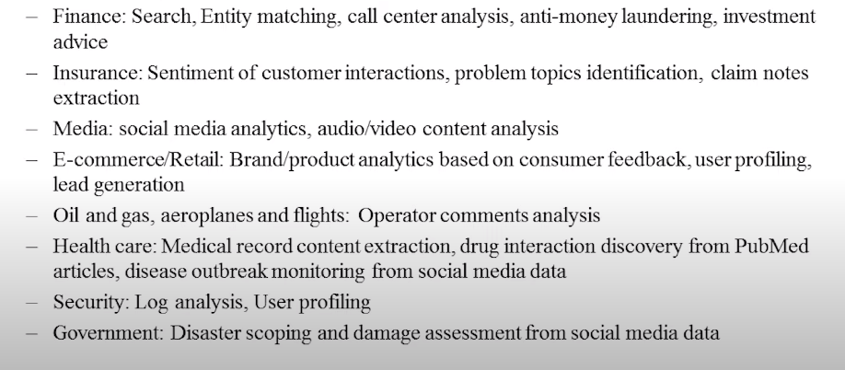

Language Technology

